**填写指南：**

**申诉说明是为了给政策组提供更全面的信息，政策组只有在有充分理由的情况下才会重新激活账户。请您花时间诚实、详细和准确的提供申诉说明和申诉资料。**

以下列出的是需要提供的常规信息和文件，填写时请注意：

* 真实性最重要：请务必根据公司的情况如实填写。
* 可适当删减：如有不适用贵司的条目，可直接删除。
* 可适当增加：申诉材料不仅限于如下所列，如贵司有其他对申诉有帮助的有力证明，请补充。
* 照片要求：尽量选择有公司名字或Logo、且具有代表性的图片。充分证明真实性，且画面质量清晰。
* 书写规范：申诉信内容要求英文书写，完成后请删除填写指南

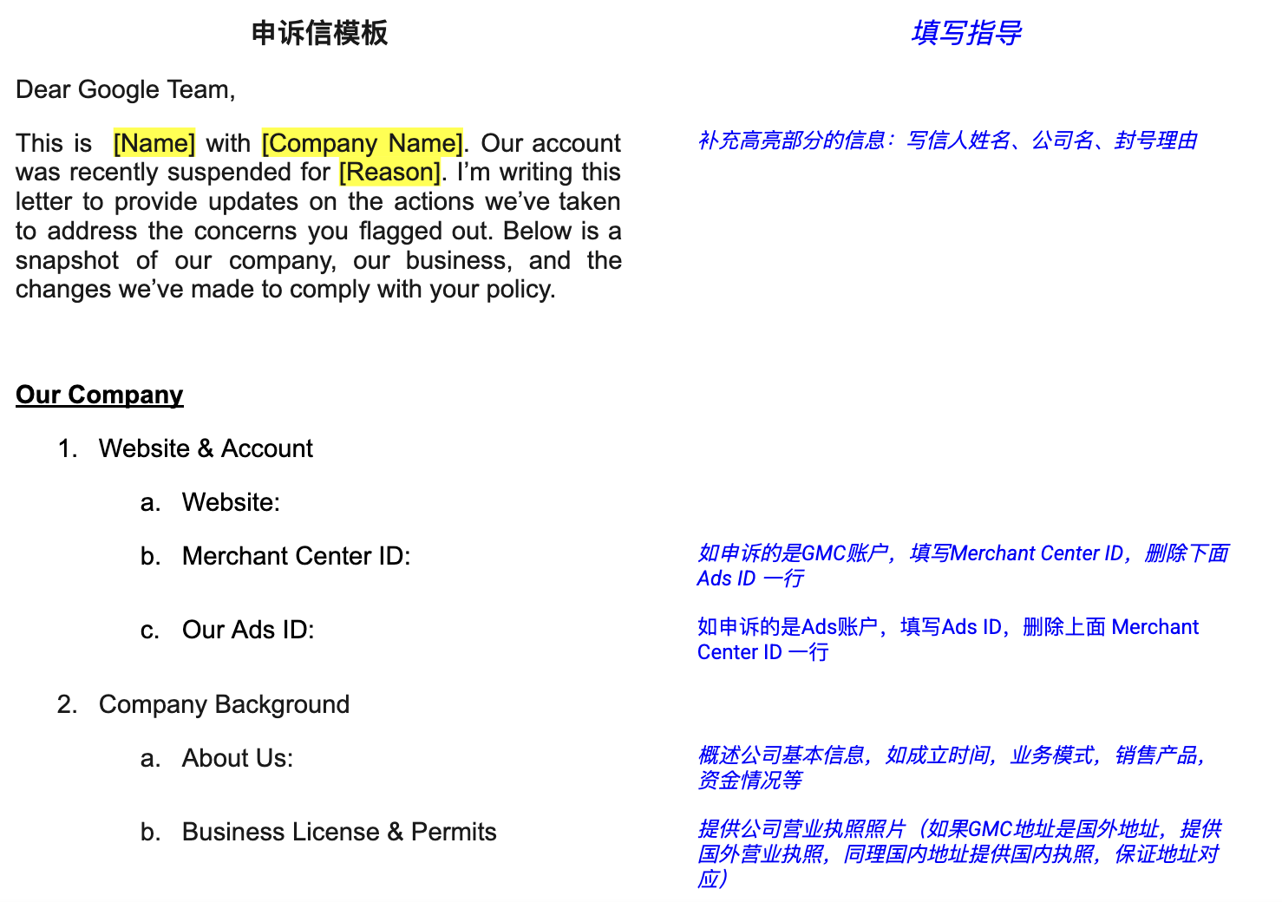

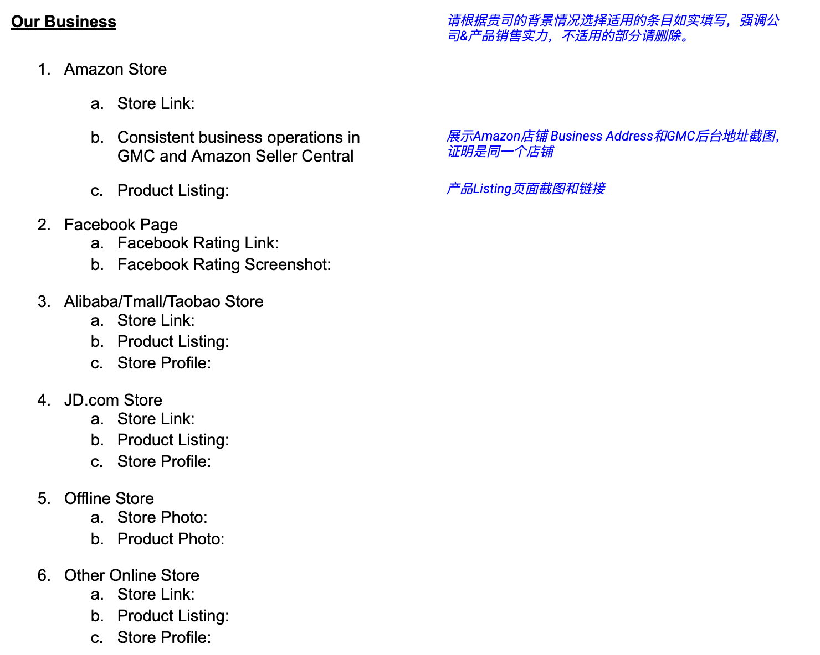

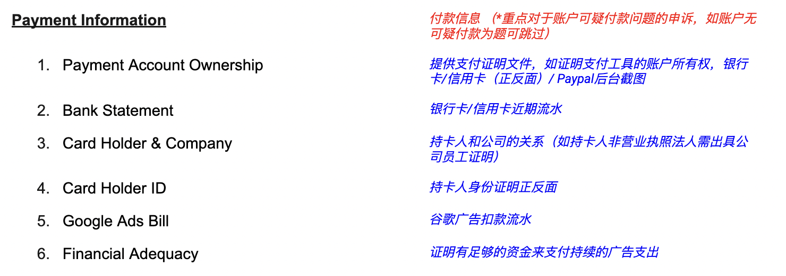

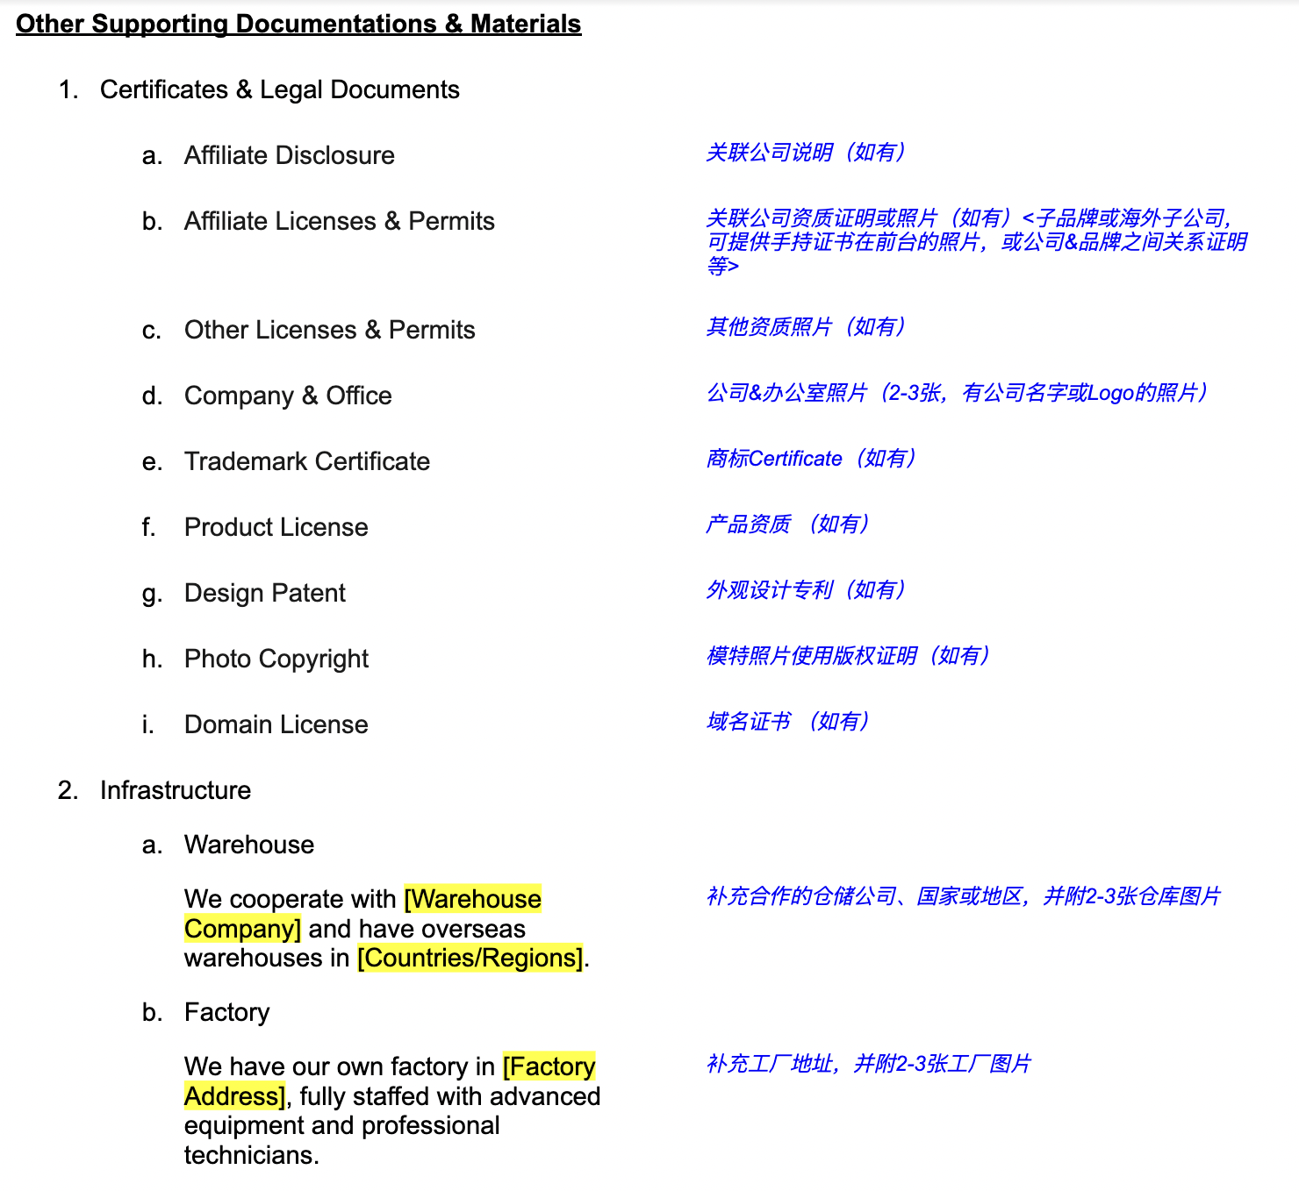

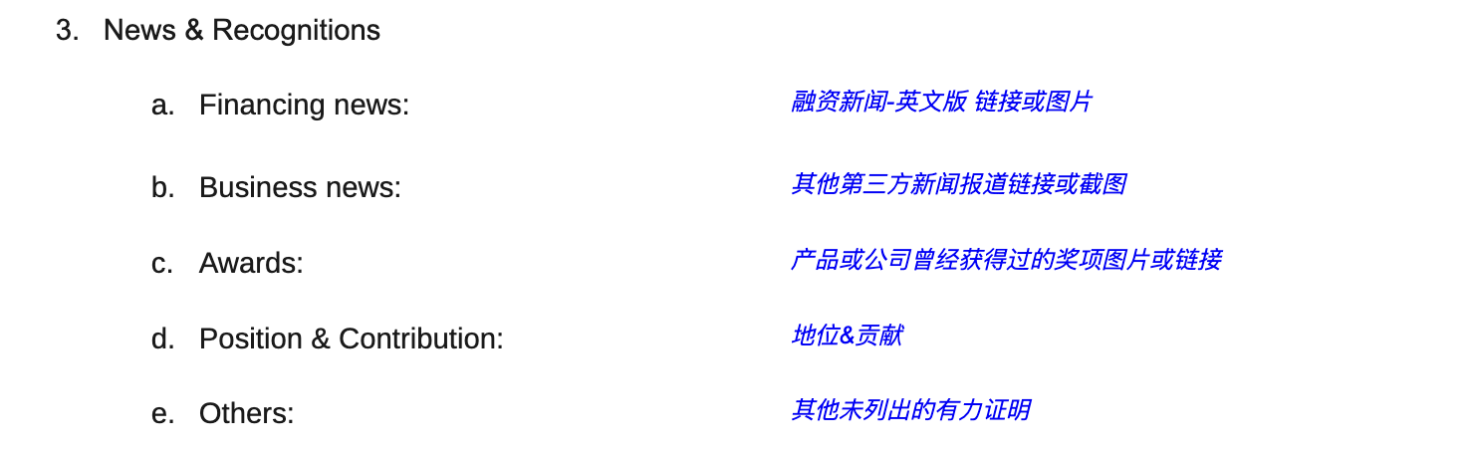

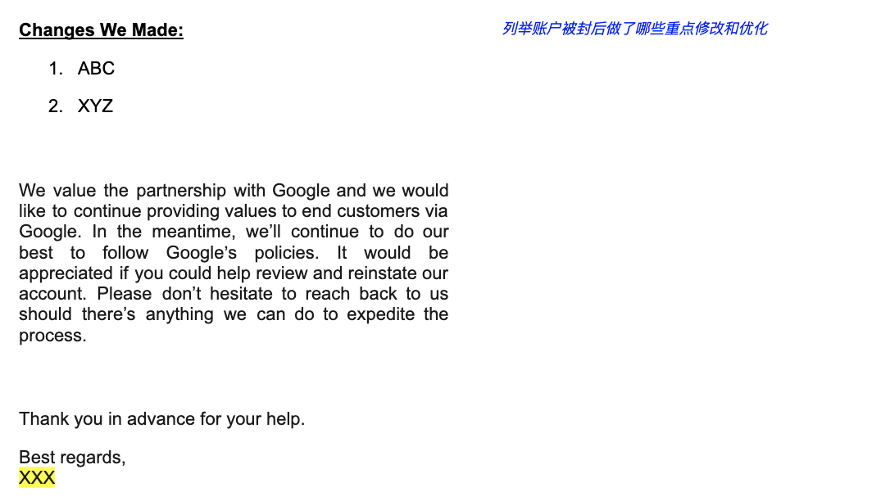

正式提交申诉信时请删除填写指南

Dear Google Team,

This is [Name] with [Company Name]. Our account was recently suspended for [Reason]. I’m writing this letter to provide updates on the actions we’ve taken to address the concerns you flagged out. Below is a snapshot of our company, our business, and the changes we’ve made to comply with Google policy.

**Our Company**

1. Website & Account
   1. Website:
   2. Merchant Center ID:
   3. Our Ads ID:
2. Company Background
   1. About Us:
   2. Business License

**Our Business**

1. Amazon Store
   1. Store Link:
   2. Consistent business operations in GMC and Amazon Seller Central
   3. Product Listing:
2. Facebook Page
   1. Facebook Rating Link:
   2. Facebook Rating Screenshot:
3. Alibaba/Tmall/Taobao Store
   1. Store Link:
   2. Product Listing:
   3. Store Profile:
4. JD.com Store
   1. Store Link:
   2. Product Listing:
   3. Store Profile:
5. Offline Store
   1. Store Photo:
   2. Product Photo:
   3. Other Online Store
6. Store Link:
   1. Product Listing:
   2. Store Profile:

**Payment Information**

1. Payment Account Ownership
2. Bank Statement
3. Card Holder & Company
4. Card Holder ID
5. Google Ads Bill
6. Financial Adequacy

**Other Supporting Documentations & Materials**

1. Certificates & Legal Documents
   1. Affiliate Disclosure
   2. Affiliate Licenses & Permits
   3. Other Licenses & Permits
   4. Company & Office
   5. Trademark Certificate
   6. Product License
   7. Design Patent
   8. Photo Copyright
   9. Domain License
2. Infrastructure
   1. Warehouse

We cooperate with [Warehouse Company] and have overseas warehouses in [Countries/Regions].

* 1. Factory

We have our own factory in [Factory Address], fully staffed with advanced equipment and professional technicians.

1. News & Recognitions
   1. Financing news:
   2. Business news:
   3. Awards:
   4. Position & Contribution:
   5. Others:

**Changes We Made**

1. ABC
2. XYZ

We value the partnership with Google and we would like to continue providing values to end customers via Google. In the meantime, we’ll continue to do our best to follow Google’s policies. It would be appreciated if you could help review and reinstate our account. Please don’t hesitate to reach back to us should there’s anything we can do to expedite the process.

Thank you in advance for your help.

Best regards,

[Name]